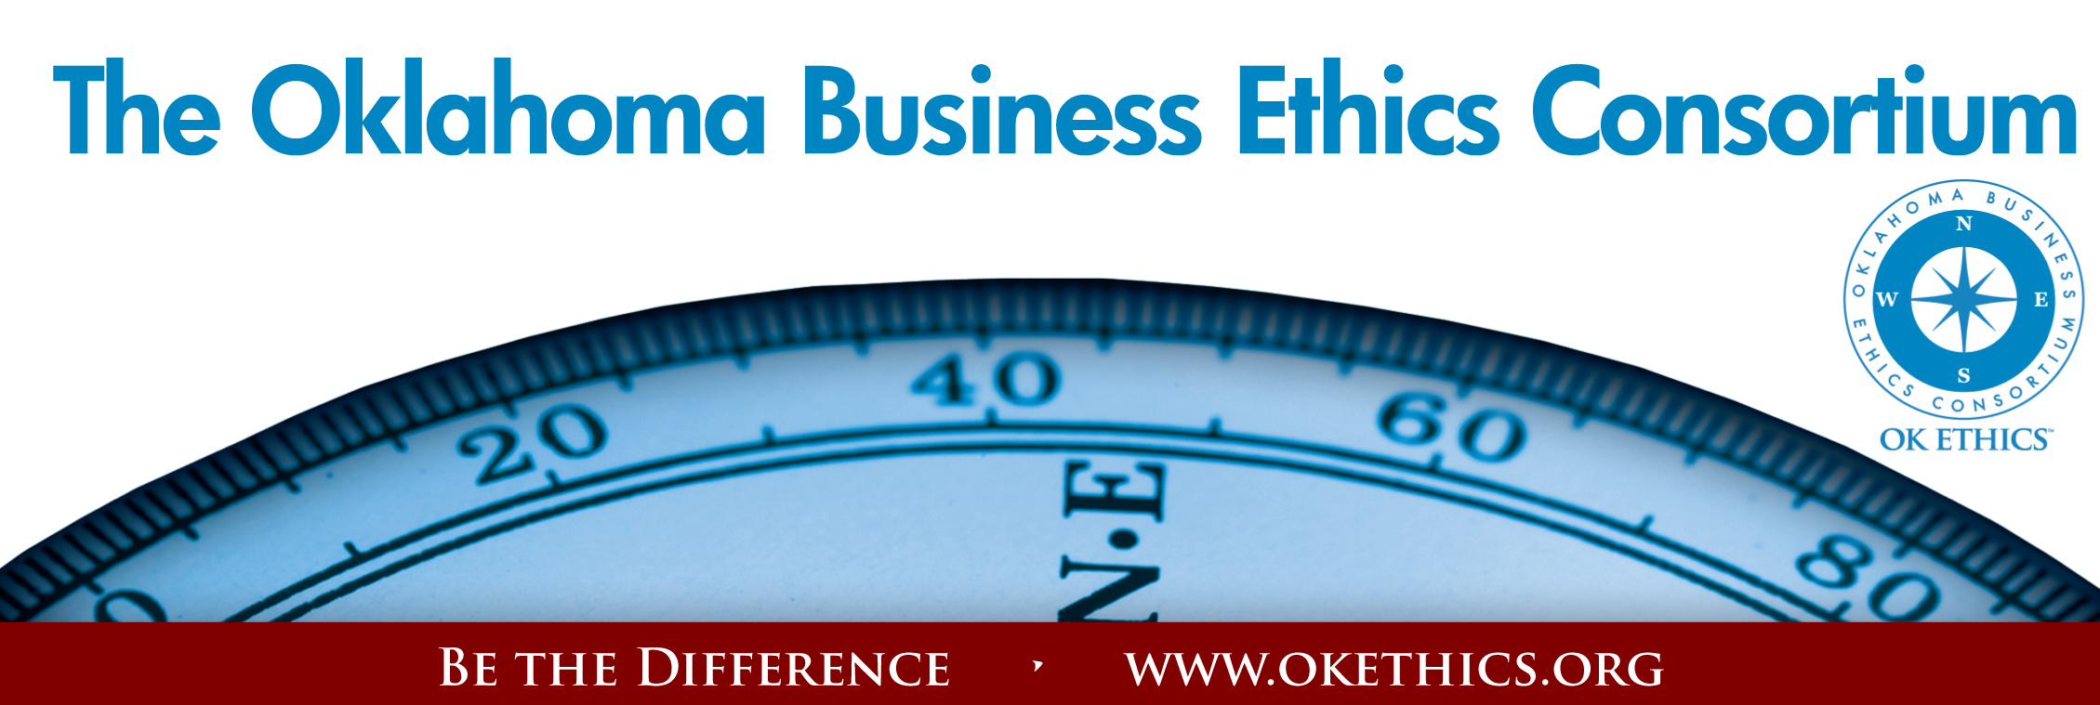
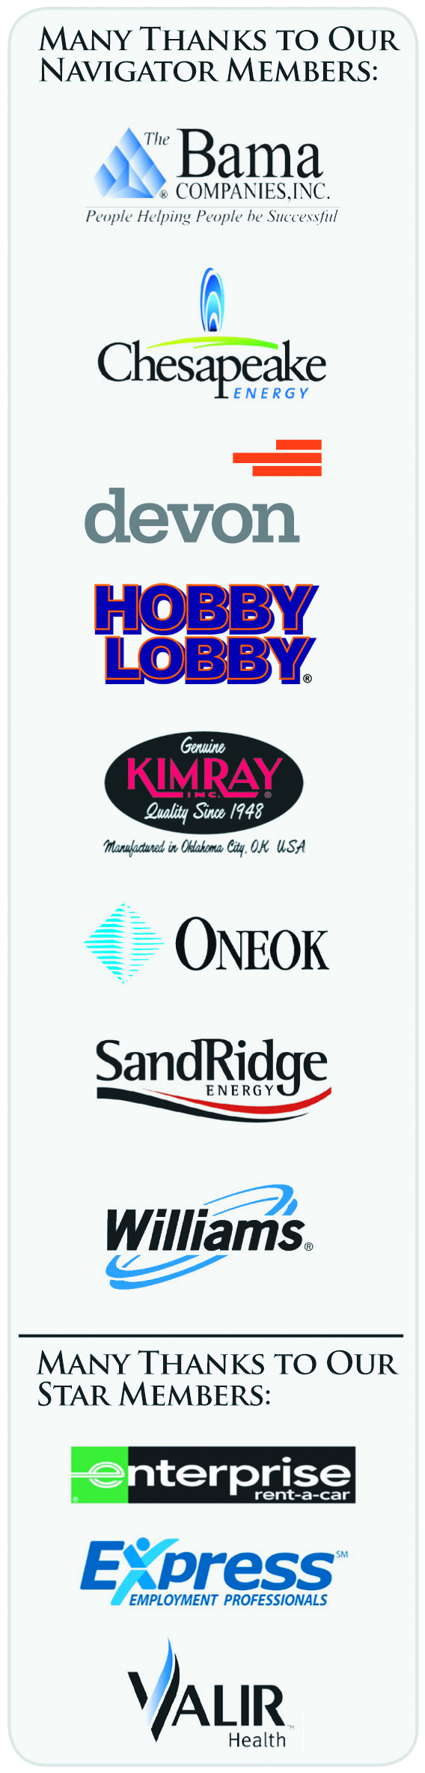

Oklahoma Business Ethics Consortium
October 22, 2009
Tulsa Chapter Meeting

I. Welcome Nick Minden, President

II. Guiding Principle Steve Rockwell, University of Tulsa

III. Membership Update Michael Oonk, Legacy Team
Membership Chairman

IV. Introduction of Panel Lynn Flinn, Legacy Team
Programs Co-Chairman

V. Program

"Ethical Dilemmas of Top Financial Officers"

Curtis Dinan – ONEOK
Mike Howard – Webco Industries
Sonja Wilson – Mazzio’s Corporation
Teresa Wuchter – Rovi Corporation

Moderator: Lynn Flinn – Rowland Group

VI. Q&A

Many thanks to our volunteers and Legacy team members for making this and every other meeting possible: Carol Swarthout, Lynn Flinn, John Stancavage, Michael Oonk, Whitney Mathews, Jan Laub, Jenny Lizama, Jennifer Lyon, Tom Clatfelter, Rhonda Bailey, David White, Shere Rockwell, Kevin Kennemer, Kari Culp and Royce Kelly.

General Disclaimer: Members of the Oklahoma Business Ethics Consortium frequently share information concerning various issues and developments that may have legal implications. The discussions, commentary, and handouts at Consortium meetings or presentations to other organizations are for general informational purposes only. They cover only some aspects of the subject topic, and do not constitute a complete legal analysis of the topic or how it might apply to any particular set of facts. Before taking any action based on information presented during a Consortium event, participants are encouraged to consult a qualified attorney. The observations and comments of presenters at Consortium meetings and networking are the views and opinions of the presenter and do not constitute the opinion or policies of the Consortium or any of its members. Presenters are respectfully requested to avoid profanity, preaching, politics and self-promotion during their lectures.

MANY THANKS TO THESE TULSA AREA COMPANIES WHO HAVE JOINED OR
RENEWED FOR FY 2009-10!!!

 | Company |  |  |  |  |  |  | Level
 | Bama Companies, Inc. |  |  |  |  |  |  | Navigator
 | ONEOK |  |  |  |  |  |  | Navigator
 | Williams Co. |  |  |  |  |  |  | Navigator
 | Helmerich & Payne, Inc. |  |  |  |  |  |  | Horizon
 | Accounting Principals |  |  |  |  |  |  | Leading
 | Cherokee Nation Enterprises |  |  |  |  |  |  | Leading
 | Darby Equipment Company |  |  |  |  |  |  | Leading
 | PricewaterhouseCoopers LLP |  |  |  |  |  |  | Leading
 | Road Science, LLC |  |  |  |  |  |  | Leading
 | Rowland Group |  |  |  |  |  |  | Leading
 | Spirit Bank |  |  |  |  |  |  | Leading
 | Tulsa Technology Center |  |  |  |  |  |  | Leading
 | American Bank & Trust Co. |  |  |  |  |  |  | Trailblazer
 | Career Development Services |  |  |  |  |  |  | Trailblazer
 | People Group, LLC |  |  |  |  |  |  | Trailblazer
 | Stanfield & O'Dell, P.C. |  |  |  |  |  |  | Trailblazer
 | Air Assurance Co. |  |  |  |  |  |  | Frontier
 | Mesa Products |  |  |  |  |  |  | Frontier
 | Milam & Associates |  |  |  |  |  |  | Frontier
 | Resources Global |  |  |  |  |  |  | Frontier
 | State Chamber of Oklahoma |  |  |  |  |  |  | Frontier
 | Stinnett & Associates, LLC |  |  |  |  |  |  | Frontier
 | Tulsa Metro Chamber |  |  |  |  |  |  | Frontier
 | University of Tulsa |  |  |  |  |  |  | Frontier
 | Air-X-Changers |  |  |  |  |  |  | Scout
 | Alan Nixon |  |  |  |  |  |  | Scout
 | Deloite & Touche LLP |  |  |  |  |  |  | Scout
 | Dr. Ryan Health Coach |  |  |  |  |  |  | Scout
 | Doellefeld Associates |  |  |  |  |  |  | Scout
 | Explorer Pipeline Company |  |  |  |  |  |  | Scout
 | Falletti Weber Consulting Group, LLC |  |  |  |  |  |  | Scout
 | Gilbreath's, LLC |  |  |  |  |  |  | Scout
 | Global Payments Inc. |  |  |  |  |  |  | Scout
 | Global Power |  |  |  |  |  |  | Scout
 | Greg Genua Consulting |  |  |  |  |  |  | Scout
 | Image Electronics, Inc. |  |  |  |  |  |  | Scout
 | Jan Laub |  |  |  |  |  |  | Scout
 | Joe Charleston |  |  |  |  |  |  | Scout
 | Northeastern State University |  |  |  |  |  |  | Scout
 | Northpoint |  |  |  |  |  |  | Scout
 | Oklahoma Central Credit Union |  |  |  |  |  |  | Scout
 | RPL Management |  |  |  |  |  |  | Scout
 | Sales Ethics, Inc. |  |  |  |  |  |  | Scout
 | Smith Barney |  |  |  |  |  |  | Scout
 | Williams Co. |  |  |  |  |  |  | Scout

